PRELIMINARY TASK

Task: The given dataset contains details about organic chemical compounds including their chemical features, isomeric conformation, names and the classes in which they are classified. The compounds are classified as either ‘Musk’ or ‘Non-Musk’ compounds. Your task is to build a classification model on the given data using any Deep Learning approach that you deem appropriate viz. Multi-Layer Perceptron, CNN, RNN, etc. or you could also use transfer learning approaches through selection of appropriate pre-trained model. The data has to be split in a 80:20 ratio for training and validation datasets. You can perform whatever preprocessing and post-processing operations on the data that may help you improve the performance of your model. You are required to report the performance measures of the model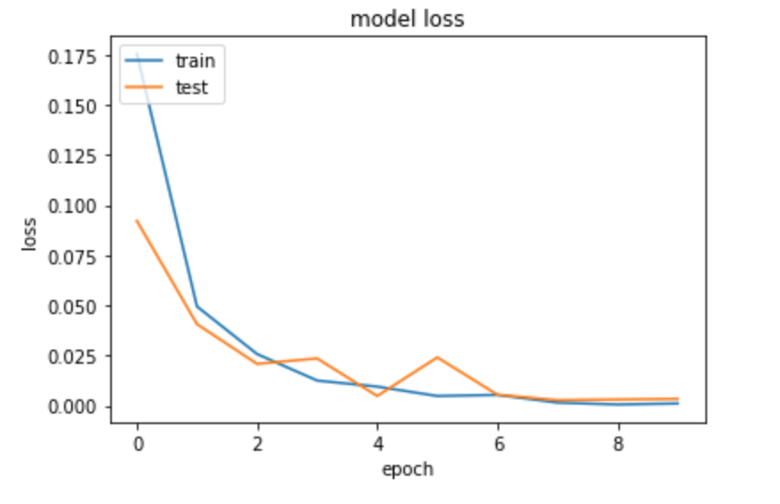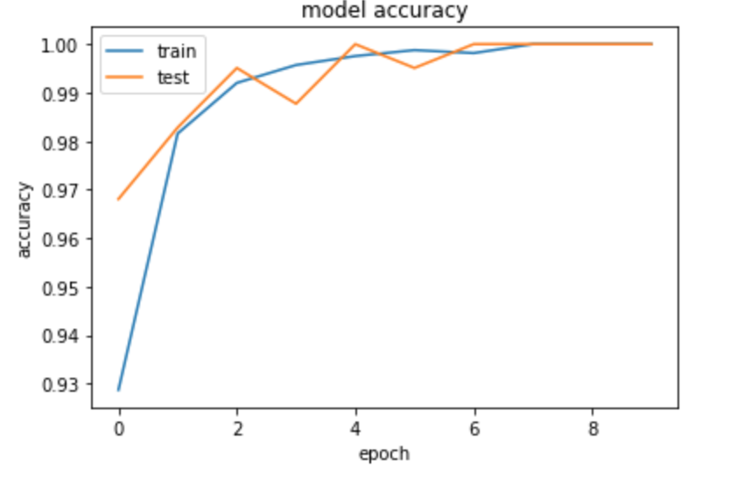 viz. Accuracy( Training and Validation) and Loss(Training and Validation) graphs, F1 score, precision, recall, etc. along with a well detailed report of what models, pre-processing, post-processing approaches you have used and why you chose to use these approaches.

Output Format:

The output must contain the following:

1. A detailed report of the model and the pre-processing and post-processing operations that you might have used along with appropriate reasons.
2. The h5 model that you have trained.
3. The Loss and Accuracy graphs in proper format. (Both Training and Validation)
4. Final performance measures of your model including validation accuracy, loss, precision, recall, F1 score.

Hint: Following are the approximate loss and accuracy curves.